# **System Requirements Specification (SRS)**

**Submitted To**

Mohammad Abdullah Al Mumin, PhD

Professor

Dept. of CSE, SUST

**Submitted By**

Sujoy Kumar Ray

2018331061

## **1. Introduction**

### **1.1 Purpose**

The purpose of this document is to provide a detailed description of the requirements for the development of a Sports Management Software System. This system aims to meet the diverse needs of stakeholders involved in cricket teams, including players, coaches, support staff, team managers, administrators, IT administrators, developers, analysts, statisticians, and administrative staff.

### **1.2 Scope**

The scope of the Sports Management Software System includes the design, development, testing, deployment, and maintenance of a comprehensive solution that covers various aspects of team management, training, performance analysis, communication, and logistical coordination.

## **2. Stakeholder Identification**

### **2.1 Users**

#### 2.1.1 Players

* Requirements:
  + Access to training schedules
  + Monitoring fitness
  + Reviewing performance data
  + Receiving communication from coaches and team management

#### 2.1.2 Coaches and Support Staff

* Requirements:
  + Planning training sessions
  + Analyzing player performance
  + Developing team strategies

#### 2.1.3 Team Managers

* Requirements:
  + Scheduling
  + Player condition management
  + Communication

#### 2.1.4 Cricket Teams (Franchise-based)

* Requirements:
  + Selection and trial purposes

### **2.2 Admins**

#### 2.2.1 IT Administrators

* Requirements:
  + Managing technical aspects
  + Ensuring proper software functioning
  + Handling technical issues

#### 2.2.2 Developers

* Requirements:
  + Creating, updating, maintaining the software
  + Implementing new features

#### 2.2.3 Analysts & Statisticians

* Requirements:
  + Statistical analysis of individual players
  + Video analysis of players' strengths and weaknesses

#### 2.2.4 Administrative Staff

* Requirements:
  + Overall team management
  + Logistics and coordination

**2.3 System Models**

Below is the Use-Case diagram for our software, Management system. Our website is about three different types of users, which are Players, Team managers, and Admin. Here are three different use-case diagrams for these three types of users.

***i***. **Players**



Figure: Use-case diagram for Players

***ii***. **Team managers**



Figure: Use-case diagram for Team Managers

***iii***. **Admin**



Figure: Use-case diagram for Admin

**3. Requirement Elicitation Process**

### **3.1 Methods**

* Conducting Interviews
* Surveys
* Observation
* Review Documentation and Validation
* Prototyping
* Feedback
* Usability Testing
* Security Testing
* Performance Testing
* Communication Testing
* Testing and Maintenance

## **4. Functional Requirements**

* User Authentication and Authorization
  + Secure login for all user roles
* Player Profiles
  + Personal information
  + Performance history
  + Fitness data
* Training Management
  + Schedule creation and management
  + Attendance tracking
* Match and Tournament Management
  + Fixture creation and scheduling
  + Tournament progress tracking
* Performance Analysis
  + Statistical data of individual players
  + Video analysis tools
* Communication Tools
  + Messaging platform for coaches, players, and staff
* Injury Tracking
  + Recording and monitoring player injuries
* Player Availability and Selection
  + Player availability tracking
  + Selection criteria and process
* Scouting and Recruitment
  + Database for potential players
  + Recruitment process management
* Document Management
  + Storage and retrieval of team documents
* Travel and Logistics Management
  + Planning and coordination of team travel
* Reports and Dashboard
  + Customizable reports for various stakeholders
  + Dashboard for quick overview
* Security and Data Protection
  + Data encryption
  + Access control mechanisms
* Feedback Mechanism
  + System for players and staff to provide feedback

## **5. Non-Functional Requirements**

### **5.1 Usability Requirement**

* UI Design
  + Intuitive and user-friendly interface
* Accessibility
  + Compliance with accessibility standards

### **5.2 Efficiency Requirement**

* Fault Tolerance
  + System should tolerate and recover from faults gracefully

### **5.3 Dependability Requirement**

* Availability
  + System availability should meet high standards

### **5.4 Performance**

* Response Time
  + System response time should be optimized
* Scalability
  + The system should scale to accommodate increased load

### **5.5 Security**

* Data Encryption
  + All sensitive data should be encrypted
* Access Control
  + Role-based access control mechanisms

### **5.6 Compatibility**

* Browser
  + Compatibility with major browsers
* Device
  + Compatibility with various devices

### **5.7 Maintainability**

* Backup and Recovery
  + Regular backups
  + Emergency recovery plan

**5.8 System Architecture**

CricWare follows the widely known MVC (Model-View-Controller) architectural pattern as the system architecture. Below is the general diagram for the MVC architectural pattern.

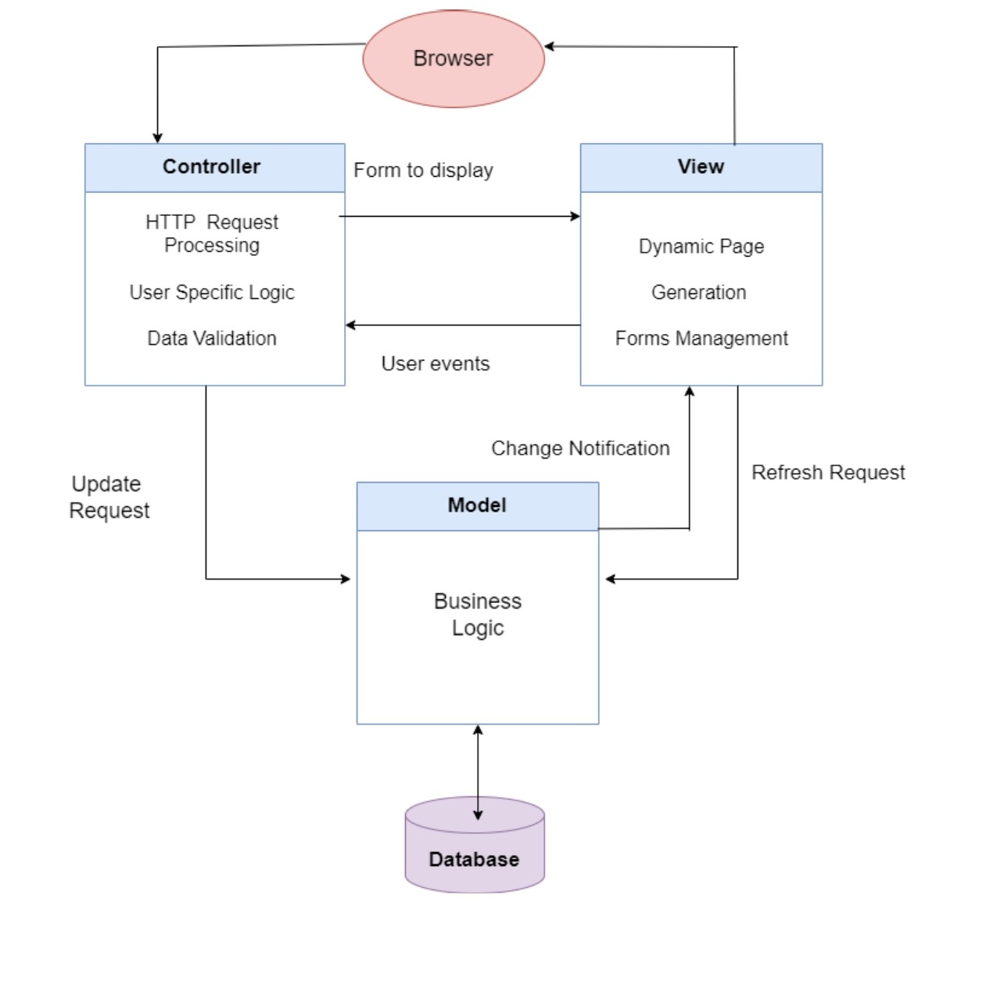

**1. Model:** The Model in CricWare would include classes or structures defining entities like User, Task, Payment, and functions/methods to interact with these entities, perform validations, and manage the data flow.

**2. View:** User interface components such as web pages, forms, and elements displaying task details, profile information, application forms, and messaging systems would be part of the View in CricWare.

**3. Controller:** In CricWare, controllers would include backend logic or server-side scripts that handle HTTP requests, validate input, trigger operations on the Model (e.g., posting a task, processing a job application), and render the appropriate View responses.

## **6. External Requirements**

### **6.1 Legal and Regulatory Compliance**

* Data Protection Laws
  + Compliance with relevant data protection laws
* Sports Governing Body Regulations
  + Adherence to regulations set by sports governing bodies

### **6.2 Integration with External Systems**

* Cricket Associations
  + Integration with cricket associations' systems
* Tournament Management Platform
  + Seamless integration with tournament management platforms

### **6.3 Security Standards**

* Industry Security Standards
  + Compliance with industry security standards
* Secure Communications
  + Encryption of communication channels

### **6.4 Scalability**

* Team Growth
  + System should accommodate the growth of the team
* Tournament Participation
  + Scalability to handle increased tournament participation

### **6.5 Technological**

* Device and Platform Compatibility
  + Compatibility with various devices and platforms
* Network Infrastructure
  + Requirements for network infrastructure

### **6.6 Budget**

* Financial Considerations
  + Adherence to budget constraints

### **6.7 Operational**

* Team Travel Logistics
  + Considerations for operational logistics during team travel

### **6.8 Support and Maintenance**

* Regular Maintenance
  + Periodic system updates and maintenance
* User Support
  + Adequate user support mechanisms

This System Requirements Specification (SRS) serves as a comprehensive document outlining the functional and non-functional requirements, as well as external dependencies and considerations for the Sports Management Software System. It provides a detailed guide for the development team to implement a system that meets the needs of various stakeholders in the cricket team ecosystem.